**DBMS ASSIGNMENT 3**

**CLASS: TE B**

**ROLL NO: 322008**

**Problem Statement:** Design at least 10 SQL queries for suitable database application using SQL DML statements: Insert, Select, Update, Delete with operators, functions, and set operator.

**Screenshots:**

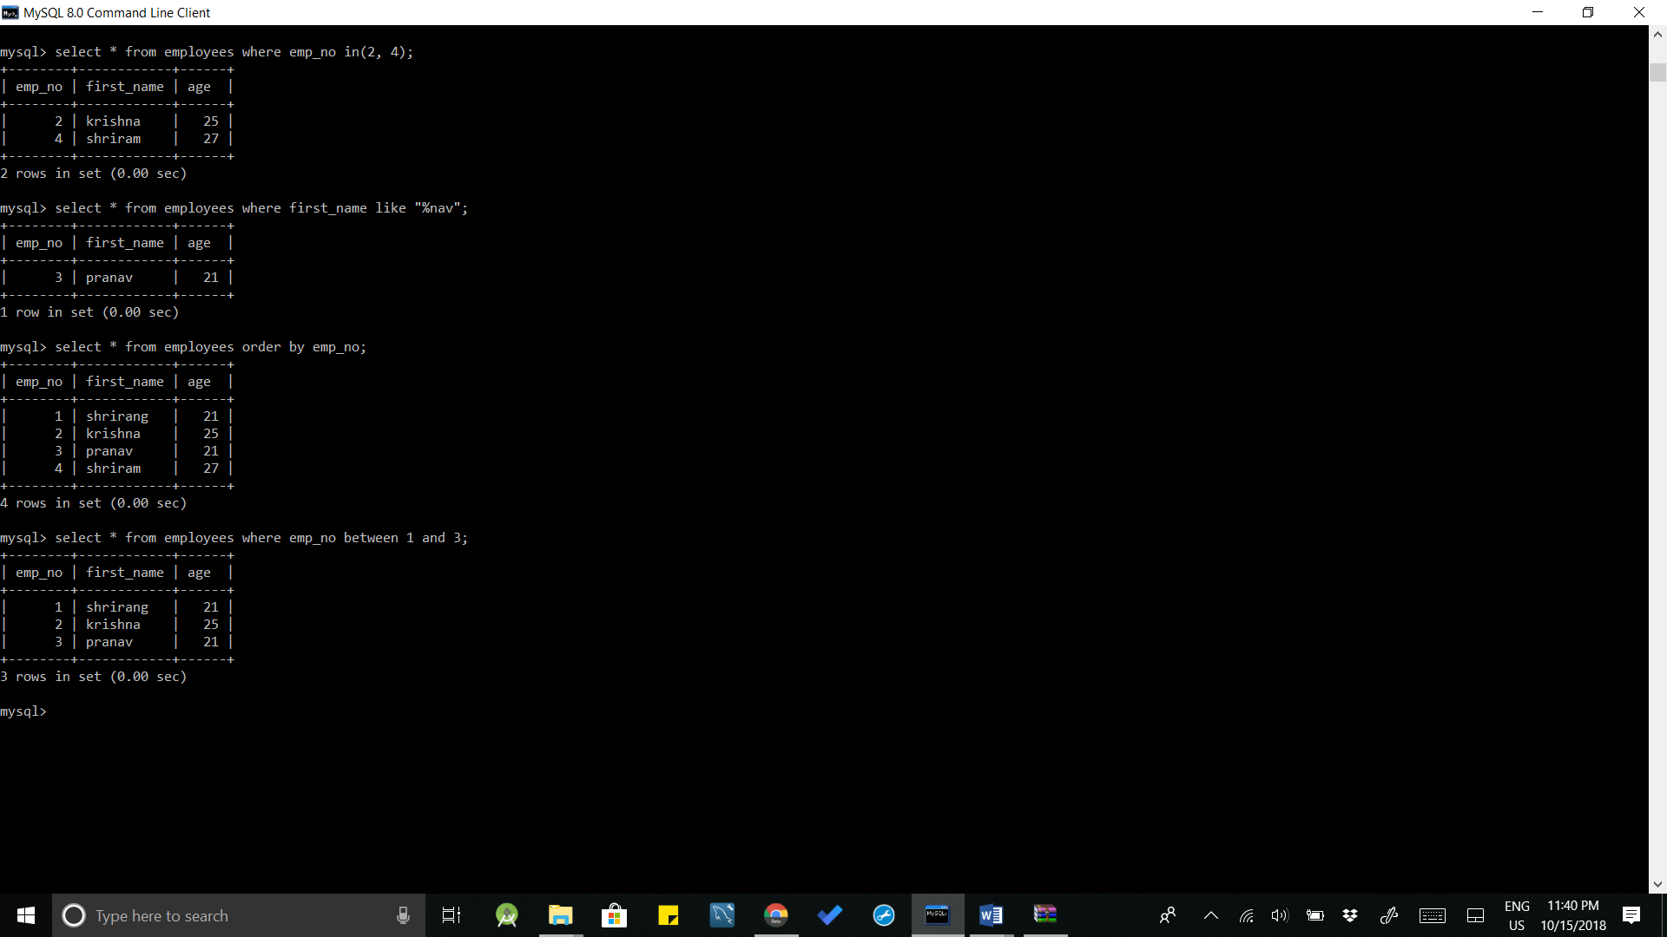

**Queries:**

1. Select * from employees where emp_no in(2, 4);
2. Select * from employees where first_name like “%nav”;
3. Select * from employees order by emp_no;
4. Select * from employees where first_name like “%nav”;

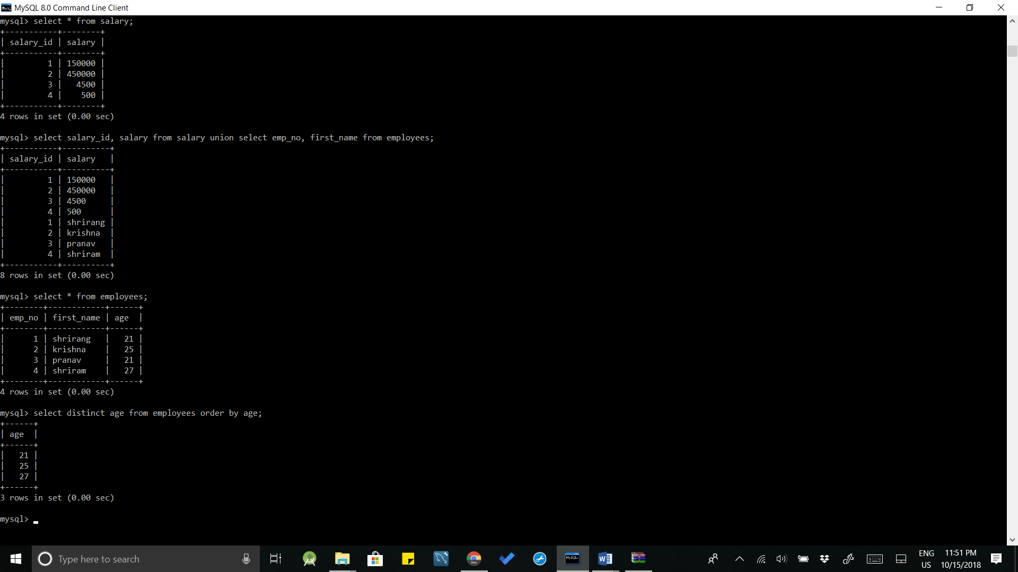

**Queries:**

1. Select * from salary;
2. Select salary_id, salary from salary union select emp_no, first_name from employees;
3. Select * from employees;
4. Select distinct age from employees order by age;

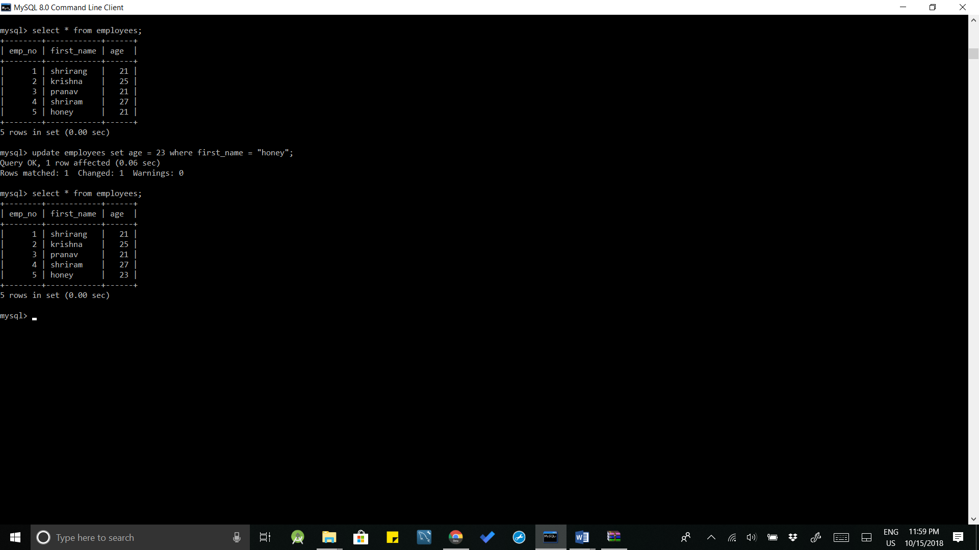

**Queries:**

1. Select * from employees;
2. Update employees set age = 23 where first_name = “honey”;

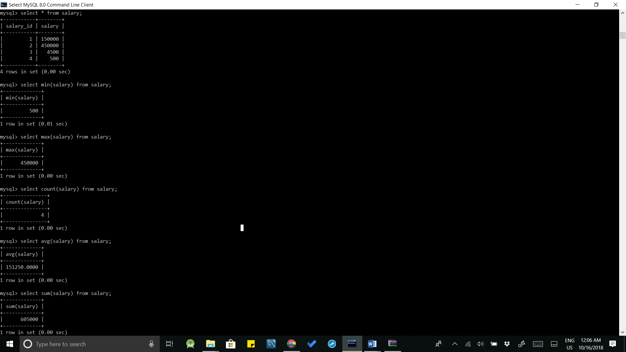

**Queries:**

1. Select * from salary;
2. Select min(salary) from salary;
3. Select max(salary) from salary;
4. Select count(salary) from salary;
5. Select avg(salary) from salary;
6. Select sum(salary) from salary;

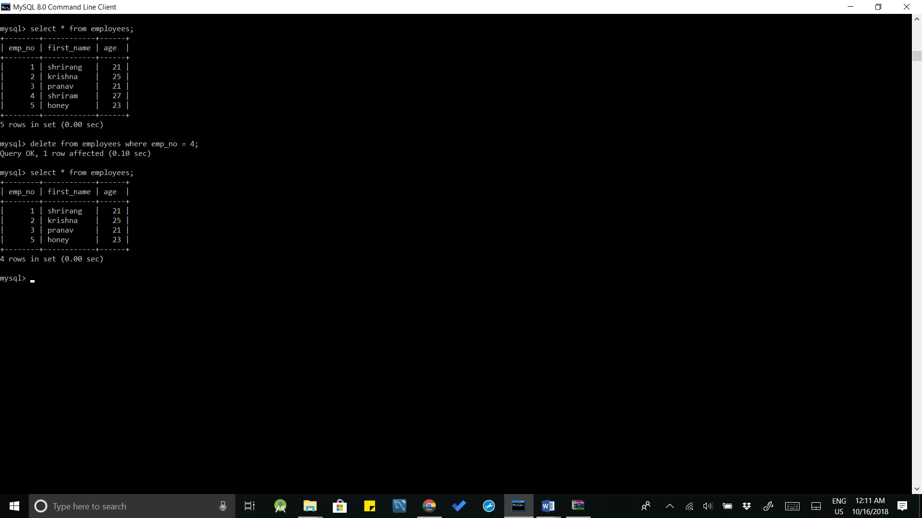

**Queries:**

1. Select * from employees;
2. Delete from employees where emp_no = 4;
3. Select * from employees;

**Conclusion:** 10 SQL queries using SQL DML statements: Insert, Select, Update, Delete with operators, functions, and set operator were implemented successfully.